Challenge 1
Advanced Software Engineering
Sreekailash Depuru (12) and Kishore Muniswamy (25)

Design
- Architecture Diagram

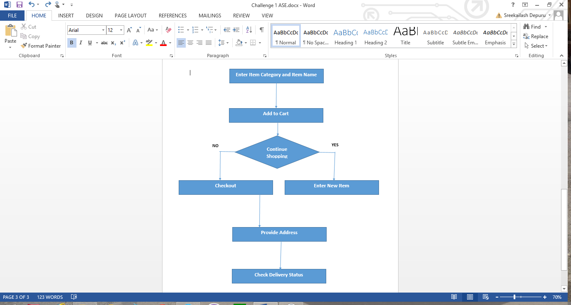

- Class Diagram
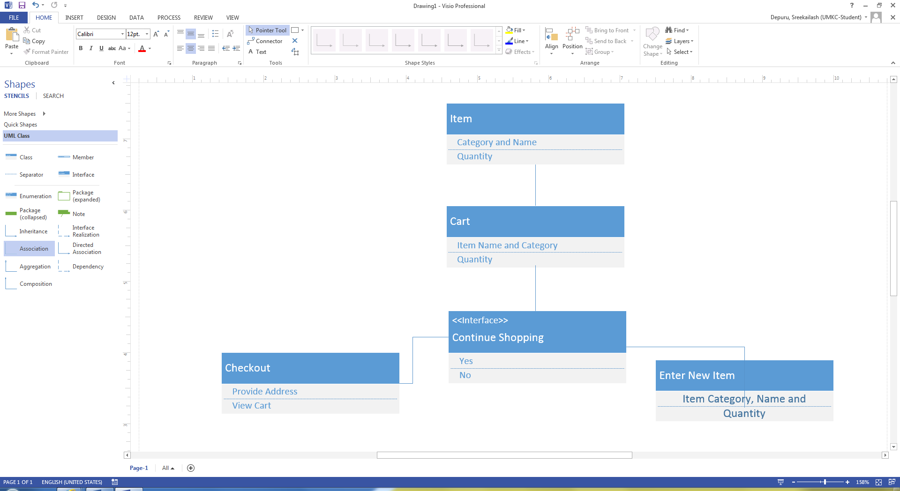

Features Implemented
The features implemented were very simple. We used jsfiddle.net for interface design. We designed the interface with all the features in it. We have not referred to any existing APIs but tried to bring out something new and simple. It means that we want to make the online grocery shopping very comfortable and user friendly so that tech savvy and non tech savvy people have an equal chance and feel at ease.
We provide features to add an item to the cart based on its category, name and quantity. The items can be further added to the cart. Once the user gets done with adding items to the cart, the next step would be to provide the address. The items will be delivered home and payment can be made on delivery.

Screenshots of the features:
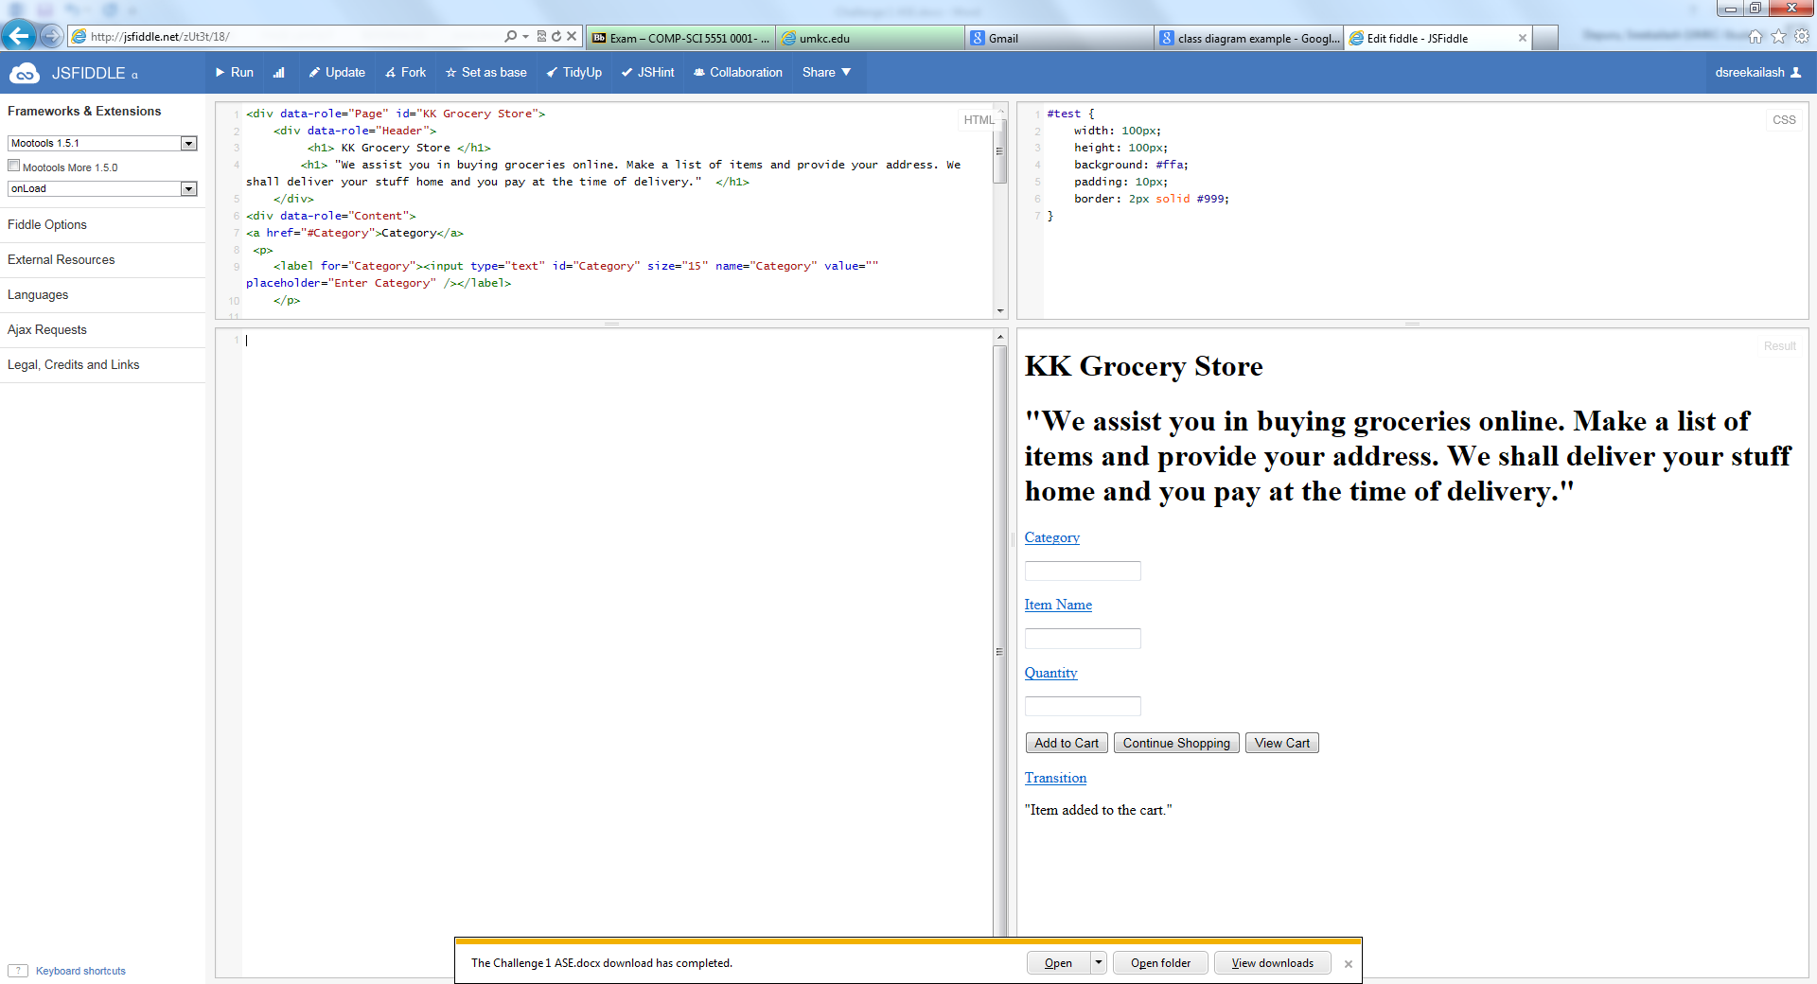

GitHub URL

Limitations:
The only limitation in our program is that we could not add online payment option. Online payment can include paying through debit/credit card and it makes it even easier. Also, we can include a feature to track the delivery status of the item the way amazon.com provides. It would make it easy for the customer to know when the items will be delivered.
These limitations if addressed can make it a very powerful app for online shopping of groceries. Grocery shopping is comparatively simple when we look at other online shopping portals. The only difference here is that people need not take their cars to the stores and lift too many loads.

References:
http://doc.jsfiddle.net/tutorial.html
http://demos.jquerymobile.com/1.0/docs/api/data-attributes.html
https://blackboard.umkc.edu/bbcswebdav/pid-1437705-dt-content-rid-6180786_1/courses/UMKC-COMP-SCI5551-0001-40380-FS2014/cs551_T2Latest.pdf

